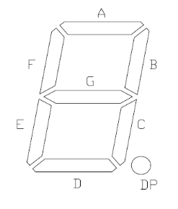
ECED2200 Lab #3 Hand-In Report
Student Name: _________________________
Student Number: _______________________
Date: _________________________________
BCD2SevenSegment Truth Table.
SW4 | SW3 | SW2 | SW1 | Decimal | 7-Seg | SEGA | SEGB | SEGC | SEGD | SEGE | SEGF | SEGG
0 | 0 | 0 | 0 |  | 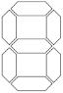
0 | 0 | 0 | 1
0 | 0 | 1 | 0
0 | 0 | 1 | 1
0 | 1 | 0 | 0 | 4 | 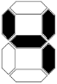 | 0 | 1 | 1 | 0 | 0 | 1 | 1
0 | 1 | 0 | 1
0 | 1 | 1 | 0
0 | 1 | 1 | 1
1 | 0 | 0 | 0
1 | 0 | 0 | 1
1 | 0 | 1 | 0
1 | 0 | 1 | 1
1 | 1 | 0 | 0
1 | 1 | 0 | 1
1 | 1 | 1 | 0
1 | 1 | 1 | 1

Part 2
- K-Map of desired truth table:
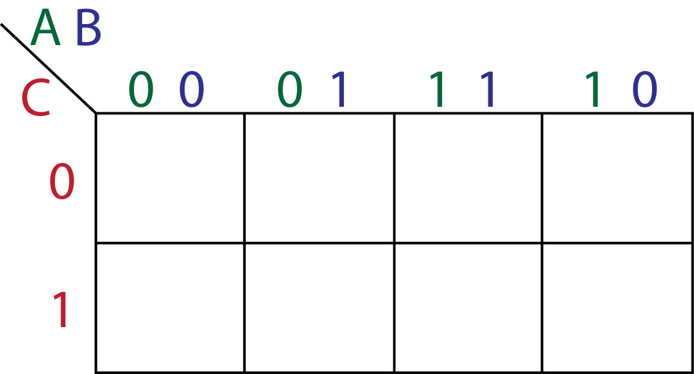
2. The simplified express from the K-Map is:
Y =
Part 2-B
A | B | C | Y
0 | 0 | 0
0 | 0 | 1
0 | 1 | 0
0 | 1 | 1
1 | 0 | 0
1 | 0 | 1
1 | 1 | 0
1 | 1 | 1

Number PTerms used = _____________
Part 2-A
A | B | C | Y
0 | 0 | 0
0 | 0 | 1
0 | 1 | 0
0 | 1 | 1
1 | 0 | 0
1 | 0 | 1
1 | 1 | 0
1 | 1 | 1

Number PTerms used = _____________
Part 2-C
A | B | C | Y
0 | 0 | 0
0 | 0 | 1
0 | 1 | 0
0 | 1 | 1
1 | 0 | 0
1 | 0 | 1
1 | 1 | 0
1 | 1 | 1

Number PTerms used = _____________

